AINT 253 Planning Document

In the first stage of AINT 253 my task is to create a door in 3DS Max which will be put into Unity and will be functional too. The task will help me develop skills in using 3DS Max to 3D model my own assets then implementing them into a game.

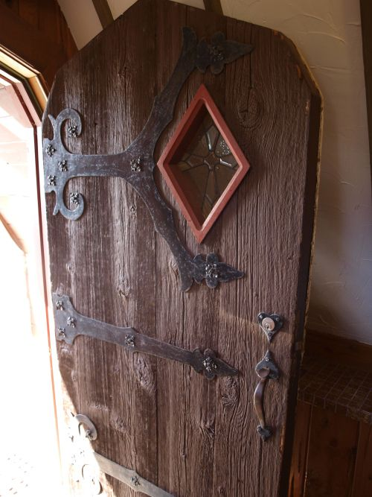Firstly; choosing the theme for the door is important as this initial decision will inform the necessary research I will have to do as well as the other features needed. This decision led to me choosing the theme of an old ship and creating a door which would fit the period; this would mean the door would be made from wood with a form of metal bolts and hinges. From deciding this other rooms would have to be created so I then started researching different parts of an old-style ship which helped me to decide how it would look overall. To the right the image shows the inspiration for the door – <https://trello.com/c/UxbUTlHn/7-pirate-ship-door-decorative> [Link to Trello Card]

Features

* Big wooden framed door
* Iron fittings (handle, hinges, decorations)
* Door would open towards the player
* Door would be lockable so player will have to find the key

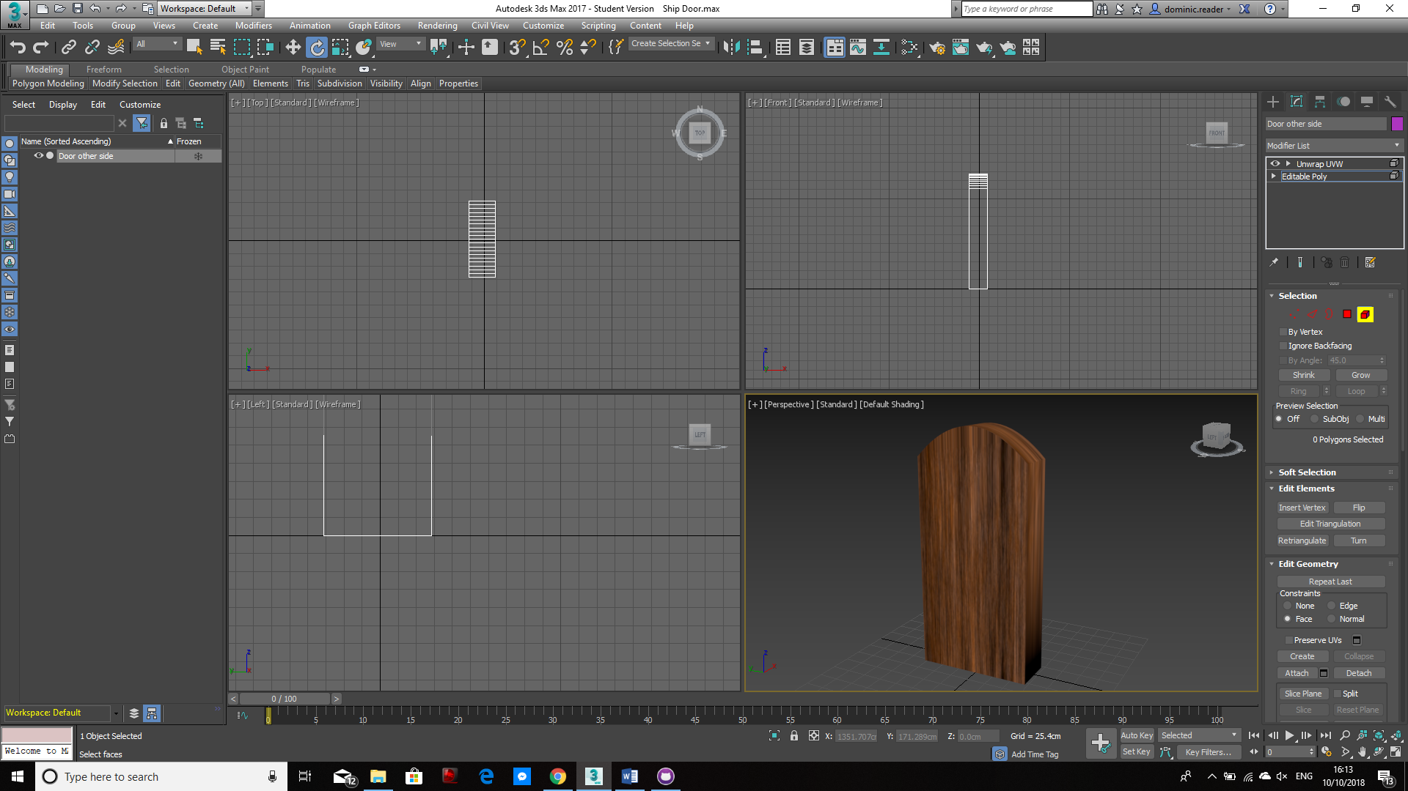After initially finding 3DS Max incredibly hard to use I was able to plan out and add a texture to the first proper attempt of creating the door. To the right is the prototype which has the wooden texture I will use applied to be able to link it to the old ship feel. Still to add to it is metal hinges and iron fittings as this will allow functionality to be achieved.